JIRA Guide

1. Go to URL <https://treasuryxpress.atlassian.net/login>
2. Type your TX email address and click continue
3. Specify the password and login

**Note: if you did not sign up yet, you have to fill your full name and a password then login**

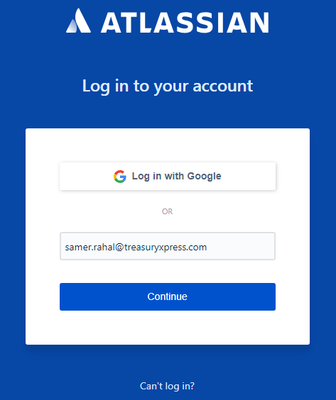

1. Once you are logged in you will be redirected to Projects sections. Projects in JIRA refer to the category (Bugs, Support, Implementation, etc….) similar to what was used in Trello.

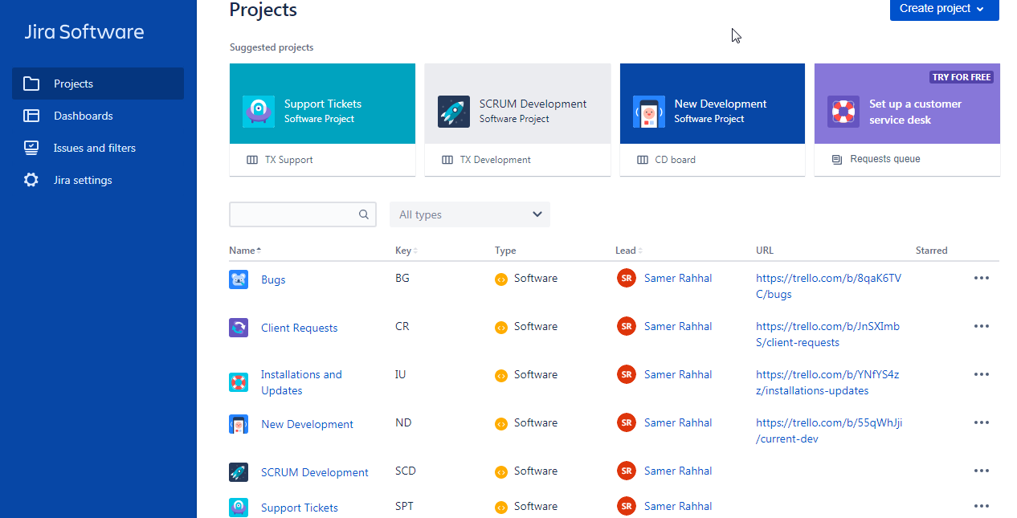

1. To report a new issue, simply type the letter “C” on your keyboard. The new issue creation form will be displayed as per below
   1. Specify the project / category: Bugs, Support or New Development (Note: SCRUM Development is for internal use to view the tasks that are being assigned during weekly iteration / SPRINTs, so kindly do not add any it).
   2. Specify the issue type (Bug or Task only): Do not use Story or Epic at this stage
   3. Specify other information (Task description, summary, attachments, assigned to etc…) and save

**Note: It is preferable to keep Assigned To / Assignee field blank unless you know which team member is responsible for the reported case.**

* 1. If you need to report another issue you can check the option “Create another” next to create button which will keep you in the same form

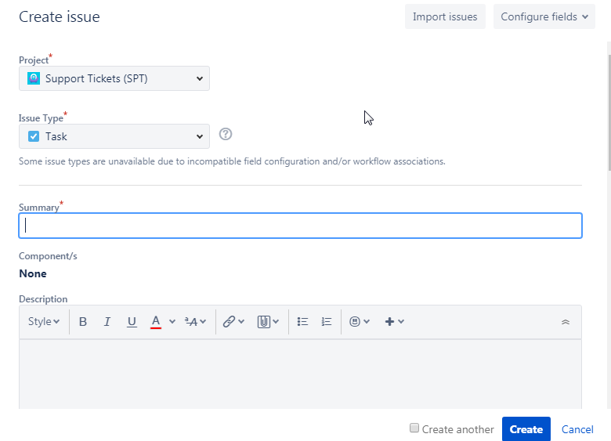

1. To view tasks or bugs within a certain category / project, go to Projects from the left panel
   1. Select your project, list of issues will be displayed (as per below). To filter issues by User select the rounded colored icon of the designated team member.

